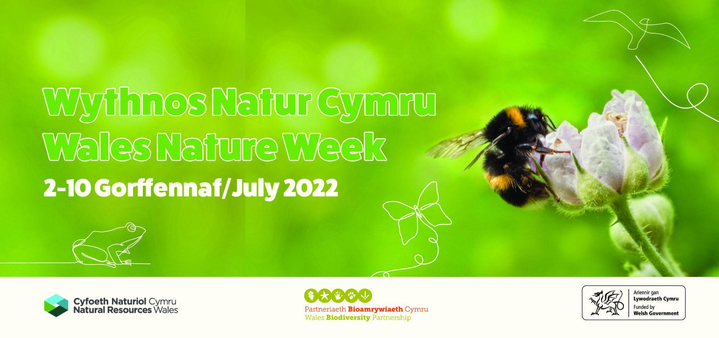

PRESS RELEASE

[Your Locality] CELEBRATES WALES NATURE WEEK 2022
WITH [EVENT]

Wales Nature Week 2022 is being celebrated in [locality] with a [name and locale of event] organised by [name of your organisation] on [date].

The [event] is one of many nature walks, talks and activity days taking place throughout Wales, organised by a range of organisations and individuals coming together for Wales Nature Week. Running between 2-10 July, the theme of this year's Wales Nature Week is ‘Get Connected - the Well-being Benefits of Nature.’

This year the organising body, Wales Biodiversity Partnership, commissioned a literature review of international studies over the past decade, which measure the benefits to the mind and body of people engaging in nature.

One study into the Japanese practice of Shinrin-yoku or forest bathing - a mindful walk through woodland - has been shown to reduce anxiety by 29%.¹

Announcing this year's programme of events, Sean McHugh of Wales Biodiversity Partnership said: “Wales Nature Week is a celebration of our oldest heritage – nature. Nature is for all of us and connecting with nature is good for our physical and mental well-being.”

The [name of local event] will include [name activities taking place in your event]
A 2013 study found that a 90 minute Nature Walk can reduce the negative thoughts known as rumination that can contribute to mental health problems². Another study in 2010 found that viewing natural scenes can lead to lower concentrations of cortisol, the ‘stress hormone’, and decrease the pulse rate and lower blood pressure³.

Organisers are also keen to encourage families to experience nature together, pointing to a 2017 study which found that access to green space can lead to improved mental well-being, overall health and cognitive development of children⁴.

For more details about Wales Nature Week 2022 and the calendar of events can visit www.biodiversitywales.org.uk/wales-Nature-week

NOTES TO EDITORS

1. The Wales Biodiversity Partnership (WBP) brings together key players from the public, private and voluntary sectors to promote and monitor biodiversity and ecosystem action in Wales. WBP is funded by Welsh Government and hosted by Natural Resources Wales.

2. Sources:

1. A Pragmatic Controlled Trial of Forest Bathing Compared with Compassionate Mind Training in the UK: Impacts on Self-Reported Wellbeing and Heart Rate Variability
by Kirsten McEwa, David Giles, Fiona J. Clarke, Yasu Kotera, Gary Evans, Olga Terebenina,,
Lina Minou, Claire Teeling, Jaskaran Basran, Wendy Wood and Dominic Weil
Sustainability 2021, 13(3), 1380; https://doi.org/10.3390/su13031380
(This article belongs to the Special Issue Psychological Benefits of Walking or Staying in Forest Areas
https://tfb.institute/press-release-uks-first-published-research-paper-into-health-benefits-of-forest-bathing/

2. Nature experience reduces rumination and subgenual prefrontal cortex activation
Gregory N. Bratman gbratman@stanford.edu, J. Paul Hamilton, Kevin S. Hahn, Gretchen C. Daily James J. Gross June 29, 2015 112 (28) 8567-8572
https://doi.org/10.1073/pnas.1510459112

3. The physiological effects of Shinrin-yoku (taking in the forest atmosphere
or forest bathing): evidence from field experiments in 24 forests across Japan
Bum Jin Park, Yuko Tsunetsugu, Tamami Kasetani, Takahide Kagawa & Yoshifumi Miyazaki
Environmental Health and Preventive Medicine Volume 15, Article number: 18 (2010) https://link.springer.com/article/10.1007/s12199-009-0086-9

4. Journal of Pediatric Nursing Volume 37, November–December 2017, Pages 3-7
Does Access to Green Space Impact the Mental Well-being of Children: A Systematic Review
RachelMcCormickMSN

-END-
ISSUED BY:
[Your contact information]

