Greater horseshoe bat Rhinolophus hipposideros

Background

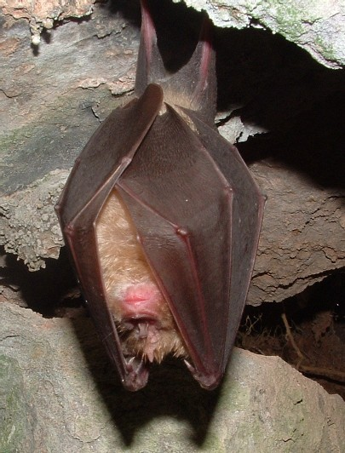
The greater horseshoe bat is one the rarest and also one of the largest bat species in Britain.

Greater horseshoe bats require a mosaic of grazed pasture, hedgerows and woodlands. Key foraging zones are up to 1km of the nursery roost for pregnant or lactating females and their young and to 4km at other times. They forage by hawking low over pasture and also ‘fly catching’ from feeding posts, usually the lower branches of hedgerow or woodland edge trees. The structure of the farmed landscape around the maternity roosts is important as well as the provision of an abundant supply of insects. Greater horseshoe bats feed on a variety of insects, but particularly on cockchafers, dung beetles and large moths. Use of avermectins can have a negative effect on the supply of insect prey.

Greater horseshoe bats rely on a variety of roost sites to provide a range of temperatures. These long-lived animals return to the same sites at the same time each year. Maternity roosts are usually in warm, dark, undisturbed large loft areas of old buildings and are used from late spring to late summer. Smaller buildings used as night roosts and stopovers between summer and winter roosts. The species hibernates underground in caves and disused mines with cool stable temperatures and high humidity and occasionally in cellars and tunnels.

Status in Wales
Range | Greater horseshoe bats have a restricted and fragmented distribution with populations scattered across south and south-west Wales. Individuals, perhaps vagrants or colonisers, have been recorded more widely, particularly in north Wales and the Welsh borders.
Population | Latest Wales Population Estimate 1480 – 2200 (2012) (http://www.jncc.gov.uk)

Threats
- Abandonment of pastoral systems and lack of grazing, particularly of cattle grazing. Dung beetles form a key component of the species diet.
- Increasing urbanisation results in loss of foraging habitat, severance of commuting routes and isolation of colonies.
- Demolition and conversion of buildings results in loss of roost sites. This species requires large open roof spaces with large access points which are easily lost when converted.

Status
Wildlife & Countryside Act 1981(as amended), Schedule 5
The Conservation of Habitats and Species Regulations 2010, Schedule 2
Natural Environment and Rural Communities Act 2006, s42
EC Habitats & Species Directive, Annex II & IV
Bern Convention, Appendix 2
Bonn Convention, Appendix 2
BAP
UK Biodiversity Action Plan
Species of principal importance for the conservation of biological diversity in Wales
Lead Partners – Natural Resources Wales

Wales BAP targets
Set in 2005 at UK level and adopted as Welsh target in 2009. Targets were set to be reviewed in 2011

Code | Target type | Target | Units | 2005* | 2010 | 2015 | 2020 | 2030
RhT1 | Range | Maintain the current range of greater horseshoe bats in Wales | Occupied 10 Km squares | 11 | 11 | 11 | 11
RhT2 | Population size | Increase greater horseshoe bat population index by 25% of the 2005 baseline level by 2020. | Population index | 100 | 110 | 115 | 125
* baseline

Actions
The following actions do not include statutory obligations with respect to species legislation, and investigation and enforcement measures of potential wildlife offences.

As a European Protected Species under the Regulation 9(5) Conservation of Habitats and Species Regulations 2010, a competent authority, must have regard to the requirements of the Habitats Directive in exercising any of their functions, so far as they may be affected by the exercise of those functions. This means that where a EPS is/or likely to be affected, then it will need to take account of the provisions provided by the Regulations.

Code | Action Type | Action | Action Lead | Ecosystem Groups | Delivery Agents
Rf1 | Habitat and Site Management | Prioritise agri-environment areas within approximately 4km of maternity roosts and significant hibernation roosts. Use agri-environment agreements to extend the amount of habitat in favourable management and improve linkages between roosts and foraging areas. | WG | Woodland,  Lowland Farmland | WG
Rf2 | Survey and Monitoring | Continue population monitoring within the National Bat Monitoring Programme. Gather and analyse additional data on population performance. Continue the use and development of automated counting systems. | BCT |  | BCT, NRW, JNCC
Rf3 | Research | Support, encourage or carry out research into the effects of climate change on the distribution and abundance of the species and strategies for minimizing the adverse impacts. | NRW
Rf4 | Habitat and Site Management | Encourage and support the favourable management of woodland within 4km of maternity sites and significant hibernacula through the use of Woodland Grant Schemes and felling licenses. | NRW | Woodland | NRW, LBAPs
Rf5 | Habitat and Site Management | Ensure the planning system protects roosts and associated foraging habitats of the species from inappropriate development. | WG |  | WG, NRW, LBAPs

LBAP areas where action is required (shaded yellow, core areas shaded green, 10km squares containing nursery roosts in red)
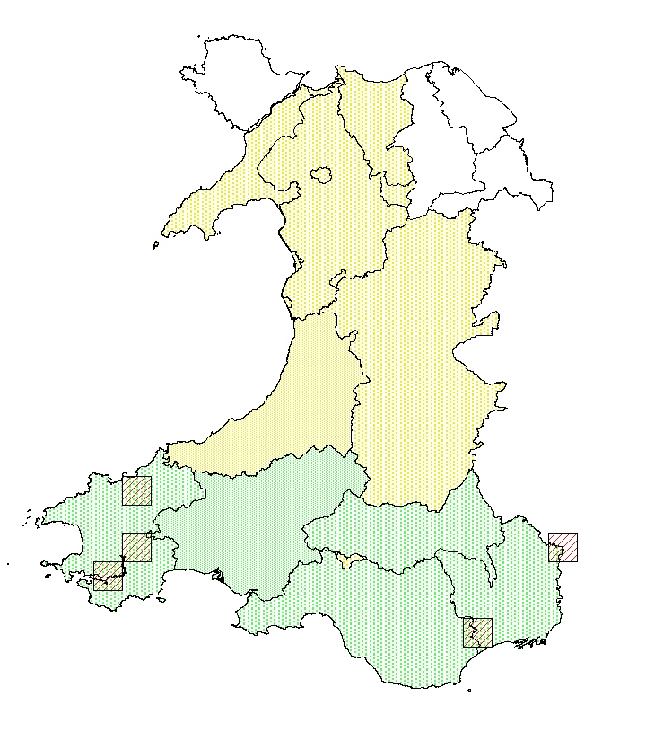

References/Links/Further Information
http://www.jncc.gov.uk/_speciespages/551.pdf (2012 link to be added)
http://www.jncc.gov.uk/page-4063
http://www.ukbap.org.uk/
http://www.bio.bris.ac.uk/research/bats/britishbats/index.htm
http://www.bats.org.uk/

Anon. (2005). Woodland management for bats. Forestry Commission England and Wales, Bat Conservation Trust, Countryside Council for Wales and English Nature.

Entwistle, A.C., Harris, S., Hutson, A.M., Racey, P.A., Walsh, A., Gibson, S.D., Hepburn, I and Johnston, J. (2001). Habitat management for bats. A guide for land managers, land owners and their advisers. JNCC, Peterborough.

English Nature. (2003). Managing landscapes for the greater horseshoe bat. English Nature, Peterborough.

