Common pipistrelle Pipistrellus pipistrellus

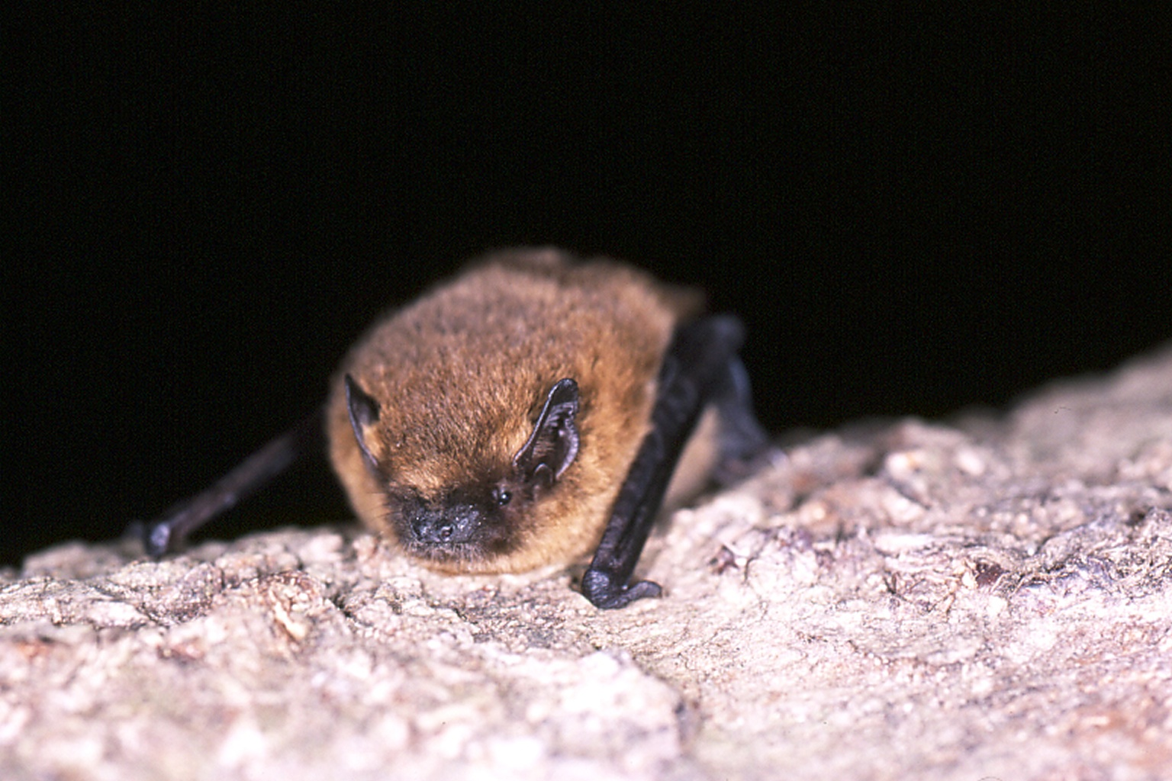
Background
Photo Hugh Clark © Bat Conservation Trust
Pipistrelles are the commonest and most widespread of all British bat species. There are two very similar species, common pipistrelle and soprano pipistrelle.

They feed in a wide range of habitats comprising woodland, hedgerows, grassland, farmland, suburban and also urban areas. Their diet consists mainly on a wide range of small flies as well as the aquatic midges and mosquitoes.

Summer roosts of both common and soprano pipistrelles are usually found in crevices around the outside of often newer buildings, such as behind hanging tiles, soffit and barge or eaves boarding, between roofing felt and roof tiles or in cavity walls. In winter soprano pipistrelles are found singly or in small numbers in crevices of buildings and trees, and also in bat boxes. They are often found in relatively exposed locations and rarely underground.

Status in Wales
Range | Widespread across Wales
Population | estimated numbers  Unknown in Wales  c. 1,280,000 in UK (http://www.jncc.gov.uk/pdf/article17/fcs2007-s1309-audit-final.pdf):.

Threats
(taken from http://www.jncc.gov.uk/pdf/Article17/FCS2007-S1309-Final.pdf)
- Agricultural pressures
Use of pesticides
Abandonment of pastoral systems
- Forestry practices including clearance of undergrowth
- Pollution and infilling of water bodies
- Infrastructure
- potential threats due to exclusions from domestic buildings and cavity wall insulation.

Status
Wildlife & Countryside Act 1981(as amended), Schedule 5
The Conservation of Habitats and Species Regulations 2010, Schedule II
Natural Environment and Rural Communities Act 2006, s42
EC Habitats & Species Directive, Annex IV
Bern Convention, Appendix 2
Bonn Convention, Appendix 2

BAP
UK Biodiversity Action Plan
Species of principal importance for the conservation of biological diversity in Wales

Lead Partner – Bat Conservation Trust (www.bats.org.uk)

Wales BAP targets
(set in 2009)
The target is to maintain the population of common pipistrelle in the UK and to increase the population from the base line by 2020. This is considered to be the case when the population index calculated from NBMP field surveys is maintained above 100 (ie there is no decrease in the population index indicative of a decline in actual population).

Code | Target type | Target | Units | 2005* | 2010 | 2015 | 2020 | 2025
PpiT1 | Population size | 1. Maintain common pipistrelle population above 2005 baseline level. | Population index |  | 100 | 100 | 100 | 100
PpiT2 | Population size | 2.Increase common pipistrelle population index by 35% of the 2005 baseline level by 2020 | Population index |  | 100 | 100 | 135 | 135
* baseline

Actions
The following actions do not include statutory obligations with respect to species legislation, and investigation and enforcement measures of potential wildlife offences.

As a European Protected Species under the Regulation 9(5) Conservation of Habitats and Species Regulations 2010, a competent authority, must have regard to the requirements of the Habitats Directive in exercising any of their functions, so far as they may be affected by the exercise of those functions. This means that where a EPS is/or likely to be affected, then it will need to take account of the provisions provided by the Regulations.

Code | Action Type | Action | Action Lead | Ecosystem Groups | Delivery Agents
Ppi1 | Survey and Monitoring | Continue to develop and implement population monitoring within the National Bat Monitoring Programme. | BCT (Steve Lucas) |  | BCT  LBAPs  VWT
Ppi2 | Research | Promote, support or undertake research on the potential impact of windfarms and microturbines on this species within the UK. | BCT (Steve Lucas) |  | BCT  NRW Defra
Ppi3 | Habitat and Site Management | No actions currently identified
Pp4 | Habitat creation / restoration | No actions currently identified
Ppi5 | Policy and Legislation | No action currently needed
Ppi6 | Communication and Advisory | 1. Influence standards, regulation and practice in the built environment to ensure the supply of potential bat roosts does not diminish. Promote the creation of roosting opportunities within the built environment as part of initiatives to promote energy efficiency.  2. Continue to provide practical advice to property owners with roosts thereby raising awareness of bat issues and improving relationships with roost owners. | BCT (Steve Lucas) |  | LBAPs  BCT  NRW

Implementation issues (and consideration of NEF principles)
- Work with building and insulation industry to ensure provisions made for bats
- Encourage new roost owners to sign up for monitoring and promote NBMP through domestic roost visits and talks, train volunteers to survey esp in the urban environment,
- Research mitigation techniques
- Research on windfarm and microgeneration impacts

Priority LBAP areas where action is required

All LBAP areas

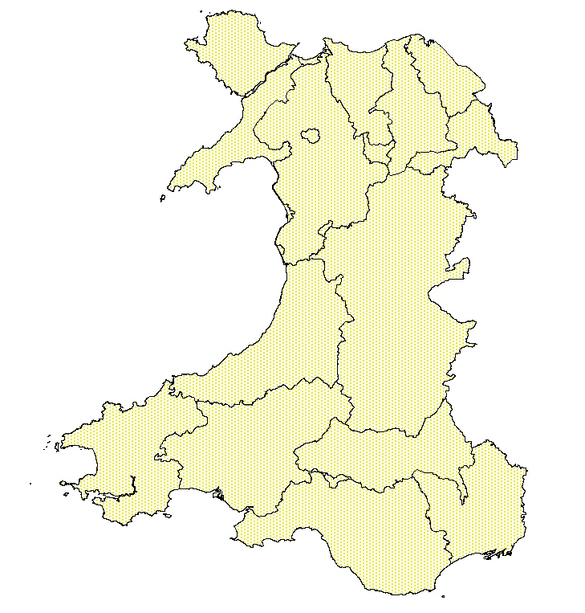

References/Links/Further Information
http://www.ukbap.org.uk/UKPlans.aspx?ID=519
http://www.jncc.gov.uk/pdf/article17/fcs2007-s1309-audit-final.pdf
http://www.ukbap.org.uk/
http://www.bats.org.uk/publications_download.php/212/commonpipistrelle.pdf
http://www.bio.bris.ac.uk/research/bats/britishbats/index.htm

